ROOM NO. - 102
01 | DHARITRI BADHAI | 2033 | 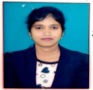  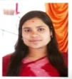
02 | GITISHREE ROUT | 2034
03 | SUMITA PADHAN | 2064 | 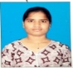
04 | SUBHASHREE MOHAPATRA | 2048 | 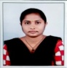
ROOM NO. - 103
01 | ANURADHA BEHERA | 2014 | 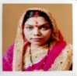
04 | ROSHNI KHETI | 2073 | 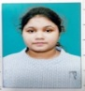
03 | GEETANJALI PRUSTY | 2009 | 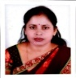
04

ROOM NO. - 105
1 | SHREETA SINGH | 2059 | 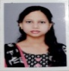
2 | NALINI RANA | 2106 | 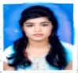
3 | SONALI SAHU | 2088
4
ROOM NO. - 104
01 | ROHINI PANDA | 2077 | 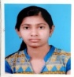
02 | ALIVA ANWESHA BAGARTY | 2074 | 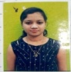
03 | ASHARANI PADHAN | 2103 | 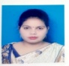  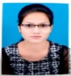
04 | MONALISHA MISHRA | 2069

ROOM NO. - 106
01 | EKTA MALLIK | 2047
02 | SURABHI GUPTA | 2054
03 | BARSHA MEHER | 2002 | 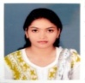  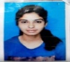
04 | JYOSHNAMAYEE MISHRA | 2004
ROOM NO. - 108
01 | SWAGATIKA BISWAL | 2095 | 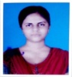  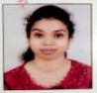
02 | ANKITA HOTA | 2107
03 | SANTOSHINI KHURA | 2088 | 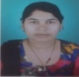
04 | D. BIJAYASHANTI PATRO | 2097 | 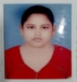

ROOM NO. - 114
01 | MONALISHA PADHAN (FAMILY) | 2035 | 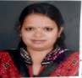
ROOM NO. - 111
01 | JAGNYASINI MISHRA (FAMILY) | 2068

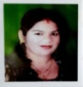
ROOM NO. - 110
01 | PRABHATI PATEL (FAMILY) | 2036
ROOM NO. - 116
01 | SUCHITRA MEHER (Guardian)

ROOM NO. - 112
01 | POOJA BHOI (FAMILY) | 2018 | 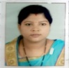
ROOM NO. - 113
01 | SWATIREKHA DANG (FAMILY) | 2052 | 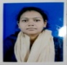

ROOM NO. - 115
01 | SOMYASHREE PANDA (FAMILY) | 2013 | 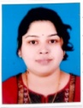
ROOM NO. - 109
01 | SUBRAT NANDA | 2076 | 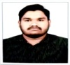
02 | SUCHITRA HOTA | 2048 | 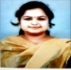

SUITE ROOM - 01
01 | NURI PANIGRAHI |  | STAFF
02 | JYOTIRMAYEE MISHRA | 2108 | 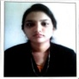
03 | ANJALI MIRDHA | 2094 | 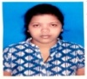
04 | LISA BEHERA | 2090 | 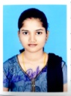
05 | JOSHNARANI PADHAN | 2093 | 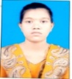
06 | MOUSUMI BAG | 2061 | 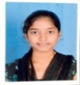
07 | PALLABI BISHI | 2053 | 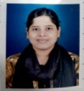
08
SUITE ROOM - 02
01 | DHARITRI SAHU | 2060 | 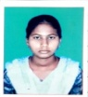
02 | HUTESHWARI BAG | 2037 | 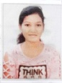
03 | ANISHA SAHU | 2054 | 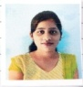
04 | RAJLAKSHMI SAHU | 2023 | 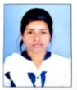
05 | BINAPANI SAHU | 2055
06 | PRIYADARSHNI BAG | 2030 | 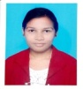
07 | SMITAMAYEE SAHU | 2051 | 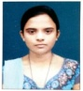
08 | BHUMISUTA THAPA | 2043 | 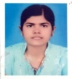

ROOM NO. - 107 (STAFF)
01 | MAHESH MEHER | STAFF | 9348826633
 |  |  | 9777988852
02 | SANTOSH  KUMAR SETH | STAFF | 9777988870
03 | BHAKTA CH. BHUKT | STAFF | 9668247205
04
ROOM NO. - 101 (GUARDIAN)
01 | JYOTIRMAYEE MISHRA (Guardian)
02 | ASHARANI PADHAN (Guardian)
03 | MOUSUMI BAG (Guardian)
04 | ANISHA SAHU (Guardian)
FOR ANY QUERIES PLEASE FEEL FREE TO CONTACT MAHESH SIR: 9348826633,9777988852

