ROOM NO. - 201
01 | ASHOK KUMAR MAHALING | 2004 | 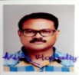
02 | DAMBARUDHAR THAKUR | 2082 | 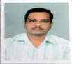
03 | BHAVIK KUMAR LAL | 2029
04
ROOM NO. – 202
01 | SASWAT KUMAR PANIGRAHI | 2092 | 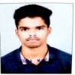
02 | BIKASH RANJAN SARAF | 2105 | 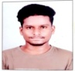  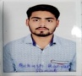
03 | TANMAYA KUMAR BARIK | 2104 | 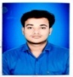
04 | SUBRAT SINGH | 2096

ROOM NO. – 203
1 | LALIT KANTA BEHERA | 2011 | 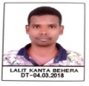
2 | GANGADHAR BHOI | 2016 | 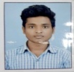  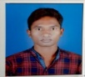
3 | MUKESH CHARAN DEEP | 2072
4 | JUGAL KISHOR BEHERA | 2080 | 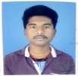
ROOM NO. – 204
01 | PRAHALLAD DHARUA | 2083 | 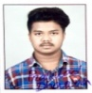
02 | MANASH RANJAN MEHER | 2079 | 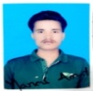  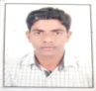
03 | MANAS AMAT | 2066
04 | MAHESH PANDA | 2098 | 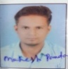

ROOM NO. – 205
1 | LOKNATH MEHER | 2084 | 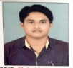
2 | KESHAB CH. SAHU | 2078 | 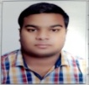
3 | SRIKANTA SAHU | 2075 | 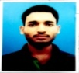
4 | SACHIN MANOJ PADHAN | 2076 | 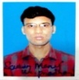
ROOM NO. - 209
01 | SWAROOP RANJAN JOSHI | 2035 | 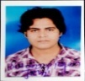
02 | BISWANATH DALAPATI | 2015 | 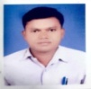
03 | SANJAYA KUMBHAR | 2038 | 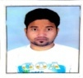
04 | ROHIT KUMAR SAHU | 2025 | 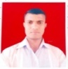

ROOM NO. - 206
01 | BIKRAM BAG | 2056 | 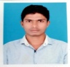
02 | ASHOK MAHANAND | 2044 | 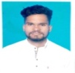
03 | SOUBHAGYA MOHAPATRA | 2026 | 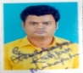
04 | BISWA RANJAN BEHERA | 2101 | 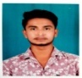
05 | BIBHISAN BAG
ROOM NO. - 207
01 | MANOJ KUMAR NAIK | 2100 | 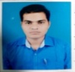
02 | SOURAV KUMAR SAHU | 2085 | 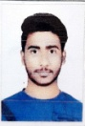
03 | PURUSOTTAM SAHU | 2091 | 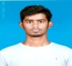
04 | SUSHRUTA HOTA | 2046 | 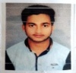
05 | SKASH SARAF | 2049 | 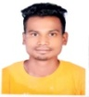

ROOM NO. - 208
01 | ANIL KUMAR SAHU | 2022 | 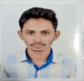
02 | KHUDIRAM CHOUHAN | 2102 | 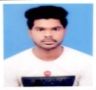
03 | RAKESH BISWAL | 2012 | 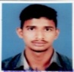
04 | PANCHANAN SAHU | 2006 | 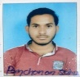
05 | SESHADEV SAHU | 2031 | 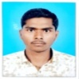

For any queries please feel free to contact with Mahesh sir: 9348826633, 9777988852

